Online Employee Management System

SOFTWARE REQUIREMENTS SPECIFICATION DOCUMENT

**Revision History**

|  |  |  |  |
| --- | --- | --- | --- |
| Date | Description | Author | Comments |
| 13/05/2020 | <Version 1> | Muhammad Aqib Bhatti | <First Revision> |
|  |  |  |  |
|  |  |  |  |
|  |  |  |  |

**Document Approval**

The following Software Requirements Specification has been accepted and approved by the following:

|  |  |  |  |
| --- | --- | --- | --- |
| Signature | Printed Name | Title | Date |
|  | Muhammad Aqib Bhatti | Supervisor | 13-05-2020 |
|  |  |  |  |
|  |  |  |  |

**Table of Contents**

1. Introduction 1

1.1 Purpose 1

1.2 Scope 1

1.3 Definitions, Acronyms, and Abbreviations. 2

1.4 References 2

1.5 Overview 2

2. The Overall Description 3

2.1 User Perspective 3

2.1.1 Operations 3

2.1.2 Site Adaptation Requirements 3

2.2 User Functions 3

2.3 User Characteristics 4

2.4 General Constraints 4

2.5 Assumptions and Dependencies 4

3. Specific Requirements 5

3.1 External Interface Requirements 5

3.1.1 System Interfaces 5

3.1.2 Interfaces 5

3.1.3 Hardware Interfaces 6

3.1.4 Software Interfaces 6

3.1.5 Communications Interfaces 6

3.2 Functional Requirements 6

3.2.1 <Project Interactivity Plan > 6

3.2.2 <System Requirements >

3.2.3< Performance requirements> 6

3.3 Use Cases 7

View User 8

GradeType 9

Add Grade 10

Add user 11 12

3.4 Classes / Objects 13

3.5 Non-Functional Requirements 14

3.5.1 Performance 14

3.5.2 Reliability 14

3.5.3 Availability 14

3.5.4 Security 14

3.5.5 Maintainability 14

3.5.6 Portability 14

3.8 Design Constraints 14

4. Analysis Models 15

4.1Waterfall Model 15

4.2 Sequence Diagrams 19

4.3 Activity Diagram 24

4.4 Data Flow Diagrams (DFD) 25

4.5 State-Transition Diagrams (STD) 26

5. Supporting Information 26

Appendix A – Background Research on: 26

Appendix B – Data Dictionary 26

# Introduction

Employee Management System is a web application developed to maintain the details of employees working in any organization. The EMS has been developed to override the problems prevailing in the practicing manual system. It maintains the information about the personal and official details of the employees.

This project aims to simplify the task of maintaining records of the employees of Company. To develop an well-designed database to store employee information Provides full functional reports to management of Company. The objective of this project is to provide a comprehensive approach towards the management of employee information.

Employee Management system is an application that enables users to create and store Employee Records. This application is helpful to department of the organization which maintains data of employees related to an organization .

Java is a platform independent language. Its created applications can be used on a standalone machine as well as on distributed network. More over applications developed in java can be extended to Internet based applications.

Thus java was chosen as background to design this application.

## Purpose

* Helps in maintaining the computerized employee details.
* Calculate the salary.
* Easy attendance marking.
* Easy calculation of various leave in categories.
* Create new users to the system accordingly.
* Manages the employees in a better way.
* Easy to find the various information related to employees.
  1. **Scope**

The scope of this project will be limited to the following:

* Employees will have access to their personal profiles and will be able to edit their details.
* Employee can ask leave.
* Employee can check is work detail.
* Admin can assign task to employees.
* Admin can approve leaves.
* Admin manage details of employees
* Login Authenticate User

## Definitions, Acronyms, and Abbreviations.

|  |  |
| --- | --- |
| Term | Description |
| Admin | Administrator |
| SRS | Software Requirement Specification |
| Org | Organization |
| EMS | Employee Management System |
| HTML | Hyper Text Markup Language |
| CSS | Cascading Style Sheet |
| AJAX | Asynchronous JavaScript and XML |

## References

[www.google.com](http://www.google.com)

[www.slideshare.com](http://www.slideshare.com)

[www.youtube.com](http://www.youtube.com)

## Overview

The Employee Management System (EMS) provides a complete information system for your employees. It can be used as a “Stand Alone” employee tracking system or it can be integrated with salary and leave information of employee of an organization. Unlike “off the shelf” human resource software that requires extensive setup time for organization use, EMS was specifically designed for helping, maintaining record of the employees of the organization.

The Employee Management System is a modular system. Its core is the Employee Demographic Module. Once entered, all demographic and historical data are available to the Employee work scheduling, Salary Management, Leave Management, and remaining details of Employee.

1. **The Overall Description**

* Every Organization where it is big or small has human resource challenge to overcome.
* EMSs provider of strategic talent management software that improves manager effectiveness and business results.
* The Employee module consists of various feature and complete information of employee in the organizations.
* The module consists of various employee management task like employee history, performance and generates reports.

## Product Perspective

The application will be contains.

### Operations

* User Employee details in the company.
* Admin can manage salary details of employee.
* Admin can view employee data easily in GUI format.
* Admin can also manage the leave detail of the employee.

## 2.2 Product Functions

According to the admin performs the following functions:

* Login module.
* Add employee.
* View details of employee.
* Edit employee details.
* Delete employee details.
* Maintain the salary details.
* Maintain leave details.

## User Characteristics

**Admin user:**

Admin can add, delete, update employee. Admin can view leave details and salary details of employee of the organization.

**Employee user:**

Employee can view his profile, can view whether his/her leave has been approved or not. Employee can update his/her profile.

## 2.4 Requirements and General Constraints

## Authentication

## Login- The user can login to the EMS system with his/her username and password.

## Logout- The user can log out from the EMS system. Login failure- If the user does not exist in the database or the user has not yet been authorized by the EMS admin.

## Authorization

## User role check- After logging in, the user role will be checked from the database and the user interface will be displayed according to their role.

## Process Data

## Display- User with defined roles can display the content of the database. Being more specific, employee can only view his/her personal information. ADMIN can not only see his/her personal information but also employee’s information who are under his/her department or school. Admin and HR can display their personal information and all employees’ information.

## Edit- A user with employee role can edit his/her specific personal information. Dean or ADMIN can only edit employees’ personal information that is under his/her coverage except user role type. Admin can edit all information related to all employees’ including their user role type.

## Search- User with ADMIN role can search the content of database for the employees’ who are under his/her coverage. Admin roles can search all the employees’ information in the database. Search feature works on specific keywords showing employee’s characteristics, peculiarities, skills, features, and etc. For example, HR wants to find employees’ who are well trained in “Java Programming Language”. He/she will write the specific keyword in the search bar and press the available search button. Afterwards, he/she will find a list of all the employees’ who know “Accounts information”.

## Update authentication- This feature can be used only by admin role type. Admin can update the role type of a specific user. For example, an employee got promotion and his role type will be changed from employee role id to ADMIN or Dean role. Admin will be able to update this authentication mechanism.

## Leave Application/Approval

## 

## Leave application- The user can be able to fill in leave application form in the appropriate fields.

## Leave approval- The admin can be able to approve leave applications based on the reasons stated, length of leave as well as available HR on a department. Leave days accrued- The user shall be able to check the number of leave days accrued.

## Recruitment

## Add new employee- HR role type is able to add a new employee to the database. The new employee will have all the required personal information related to him/her. The newcreated employee will have an id.

## Add a new user- After a new employee has being created by HR role, admin role is responsible for creating a new user by the specified id assigned in the “Add a new employee” feature. The unique id will be given by the system. Admin will assign a new role such as employee, and admin to the new created user

## 2.5 Assumptions and Dependencies

|  |  |
| --- | --- |
| GUI | Graphical user interface |
| Admin | Administrator |

# 3.Specific Requirements

This section holds every last bit those practical necessities of the framework. It will provide for the complete depiction of the framework and it Characteristics.

## 3.1 External Interface Requirements

### 3.1.1 System Interfaces

The interface for this requisition will be like sustenance record administration framework with enter record Anyway in this hold numerous every last one of point of interest from claiming bargains Furthermore area about arrangements its portraits. Is need straightforward Also an magnetic interface which may be simple will justifiable to user.



Database

Connection

### 3.1.2 Interface

The interface provide the user and admin

### 3.1.3 Hardware Interfaces

* On pc or laptop Pentium 4 or higher
* For android at least 512 ram

### 3.1.4 Software Interfaces

* Windows xp,7,8,8.1,10 , Linux, Ubuntu, mac any browsers .

#### 3.1.4.1 Microsoft SQL Server 7

Those framework utilization SQL server on store record for users. It stores his/her name there wrong doing, location for future, and the representative who included for it and the picture for user all these sections are fill in the manifestation for provision that information will spare in the database. The client Also director account login id admin Furthermore international ID also saved in the database. It matches the id admin Also secret key with those store majority of the data in the database whether match the account will open Also we utilize the result.

### 3.1.5 Communications Interfaces

* MySQL database server

## 3.2 Functional Requirements

The application will define some action that depends on

* The MySql database services are used for maintain records
* The requirement of system must be fulfilled for accurate working of the system.

**Project Interactivity Plan**:

The client will cooperation with programming by approaching those summon through machine. Provision will be client cordial because of accepting that information from that equipment. The framework indicates the clients requesting record looking into interest.

**Secure User Login:**

This programming In spite of will be client interface nothing. Yet all the at present it might require a login around situated up, with the goal that those outer danger wont botch those quick nourishment frameworks spared amount or those subscriber’s rundown.

**System Requirements:**

This programming In spite of will be client interface nothing. Yet all the at present it might require a login around situated up, with the goal that those outer danger wont botch those quick nourishment frameworks spared amount or those subscriber’s rundown**.**

* Memory Requirement = 512MB RAM
* Pentium 4 Processor

**Performance requirements**

* **Response time.**

It will be depending on the jobs and actions amount of data that is going to be processed and also depends on your system and the user.

* **Supportability**

It supports any computer system.

It supports the MySql database.

It supports the window 7, window 8 and UNIX.

Usage Scenarios:

|  |  |  |
| --- | --- | --- |
| **Use Case Title** | **View user detail** | |
| **Use Case Id** | UC001 | |
| **Description:** Registered users/User can view other online users | | |
| **Pre-Conditions:**   * users are available | | |
| **Action** | | **Exception** |
| * Registered user/User Open the Application. * Show all information of the employee. | | user  not available |
| **Post Conditions:**   * Users can show all information successfully | | |
| **Alternative path:**   * Contact with Admin | | |
| **Author:**   * Muhammad Aqib Bhatti | | |

|  |
| --- |
|  |
|  |
|  |

## 3.4 Classes / Objects

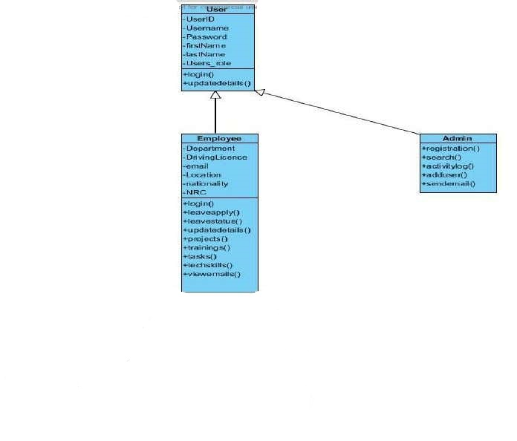

## 3.5 Non-Functional Requirements

* Login security is provided and the system will be safe from unauthorized access. The client must be logged into the system before performing any type of task.
* The system will be able to keep record of the users.
* The system will be able to keep record of the Teachers.
* The system will be able to keep record of the admin

### 3.5.1 Performance

The performance of the application will be good.

**3.5.2 *Reliability***

It will support the latest functions of the user requirements

### 3.5.3 Availability

It will be available for any Time.

### 3.5.4 Security

It will also support the privacy mode.

### 3.5.5 Maintainability

The scheduler will not support job immigration for the purpose of decreasing resource fragmentation.

### 3.5.6 Portability

This application can be use on any policy like Xp, vista, 7, 8 etc.

## 3.8 Design Constraints

Software Language: All coding will be done in standard Web programming

**4. Analysis MetAdminology**

A product improvement life cycle model is An set from claiming movements together with request association b/w exercises that In we performed done a way that fulfills with an requesting relationship b/w process fancied result. These would those Emulating product improvement life cycle models**.**

* Waterfall model
* Spiral model

**4.1 Water fall model**

This model is also known as linear sequential model. There are five stages in this model

* 1. requirement analysis and definition
  2. system and software design
  3. implementation and unit test
  4. integration and system test
  5. operation and maintenance

This model is depicted in the following diagram

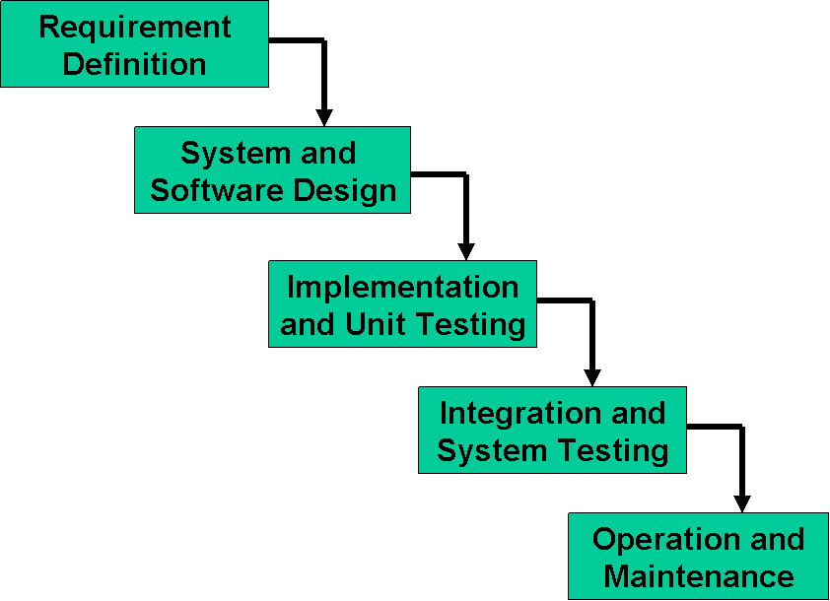

**Advantages:**

1. this model is easy to explain
2. all the activities are well defined
3. all the work is in sequences and easy to detect error
4. it can help us to plan and schedule the project
5. it is document driven model
6. it is disciplined approach

**Limitations:**

1. it can assume that requirements of system can be frozen before the design begin
2. this model is desirable for expansive projects
3. delivered product may not meet client’s need

## 4.2 Class Diagrams for client

## 

## 

## 

## Class Diagram For Employee

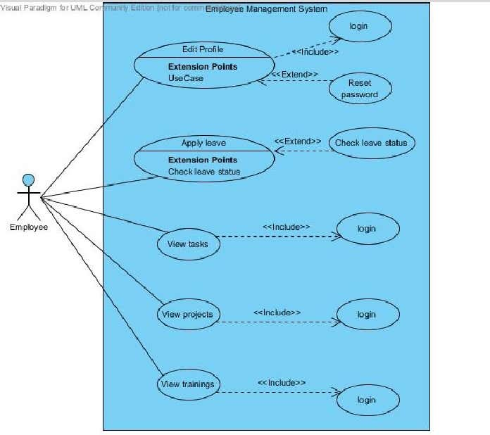

## Class Diagram For Admin

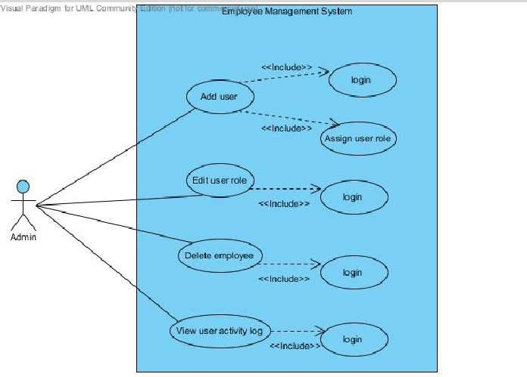

**View users**

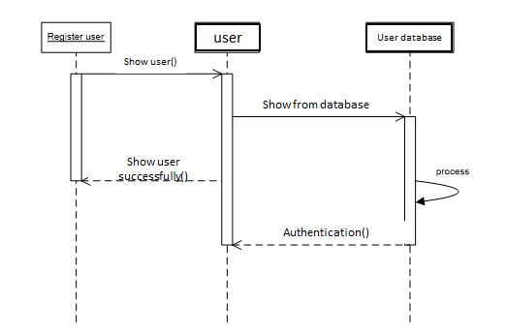

**Add User:**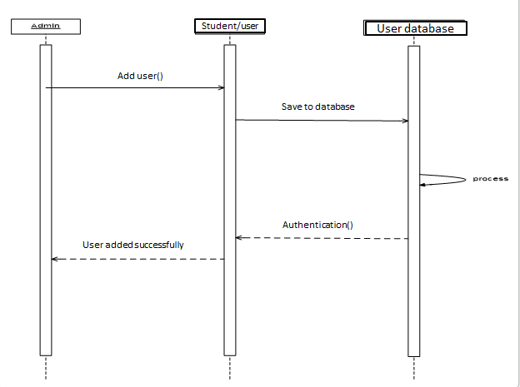

**4.3**. **ACTIVITY DIAGRAMS**

For Login module:

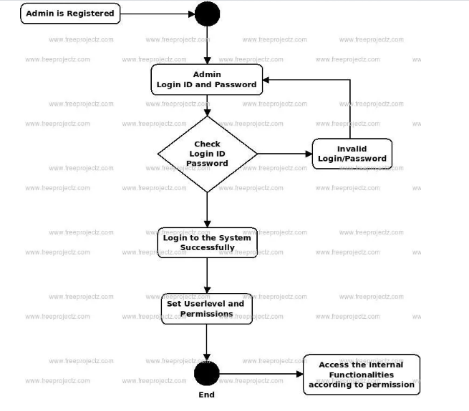

For Employee data manipulation module: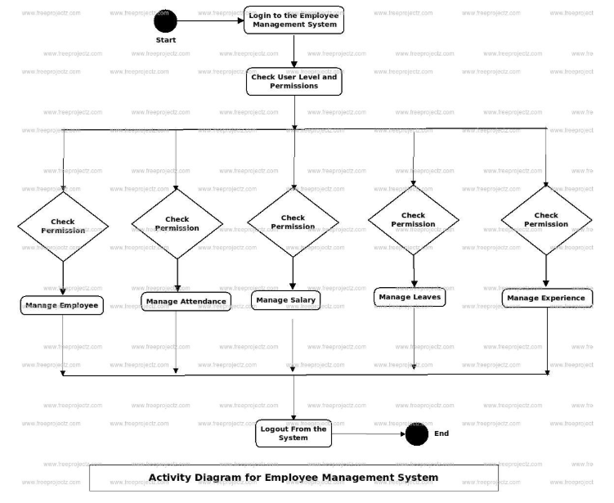

## 4.4 Data Flow Diagrams (DFD)

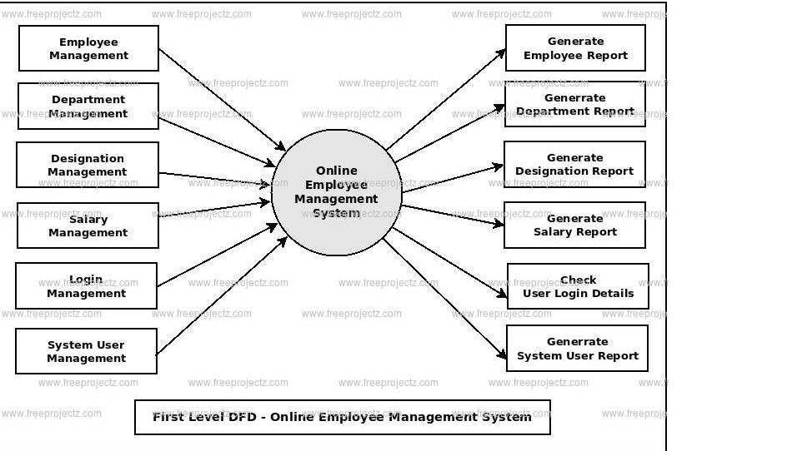

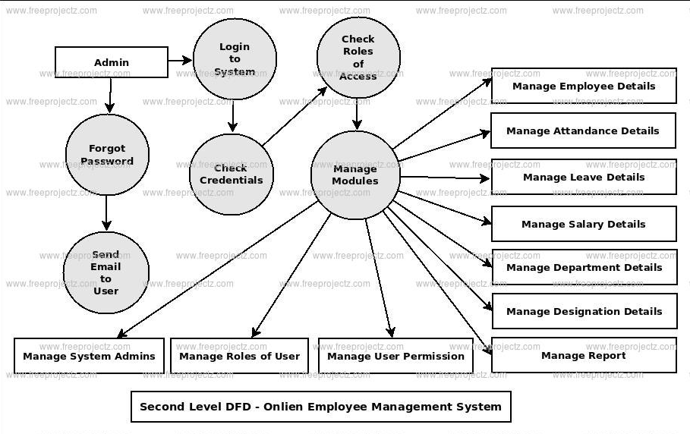

## 4.5 State -Transition Diagrams (STD)

Search an Employee

Employee salary Crud

Employee Crud

Start /sign in

Admin

Login

Admin id and password

Perform Action

Perform salary crud

Data will access from database

Stop/sign out

# 5. Supporting Information

### Appendix A – Background Research on:

**Appendix A**

**Glossary**

**Actor**

It represents a role, an external entity who interact with our system.

**Use case**

Graphical Represent of interaction among system and actor.

**Scenario**

The time of actual input and expected output.

**Use case diagram**

Represent use the services and functionality by the system by the actor.

**Use case Realization**

How the use case realizes in the design table model.

**Activity diagram**

Graphical represent of the process flow of use case etc.

**Sequence diagram**

Represents the interaction of an object to perform a job.

**Collaboration diagram**

Alternative representation of sequence diagram.

**Data model**

Represent the persistence object model.

**Appendix B**

**Web References:**

**[General]**

http://www.yourhtmlsource.com/starthere/whatishtml.html

http://www.w3.org/standards/webdesign/htmlcss

https://developer.mozilla.org/en-US/docs/Web/JavaScript/Guide/Introduction

https://en.wikipedia.org/wiki/PHP

https://dev.mysql.com/doc/refman/5.1/en/what-is-mysql.html

http://www.computerhope.com/jargon/d/dreamweaver.htm

https://en.wikipedia.org/wiki/Firefox

**[Search]**

http://www.google.com

<http://www.37.com>

http://www.yahoo.com

http://www.msn.com

http://www.mamma.com

http://www.altavista.com

http://www.ask.com

http://www.registration.com